**Solutions - Assignment 1 - Pratik**

**Github Repo:**

1. Creating and Renaming Files/Directories

Create a directory named test_dir using mkdir.

Inside test_dir, create an empty file called example.txt.

Rename example.txt to renamed_example.txt using mv  
- Created directory using mkdir and an empty file using touch, and renamed it using mv

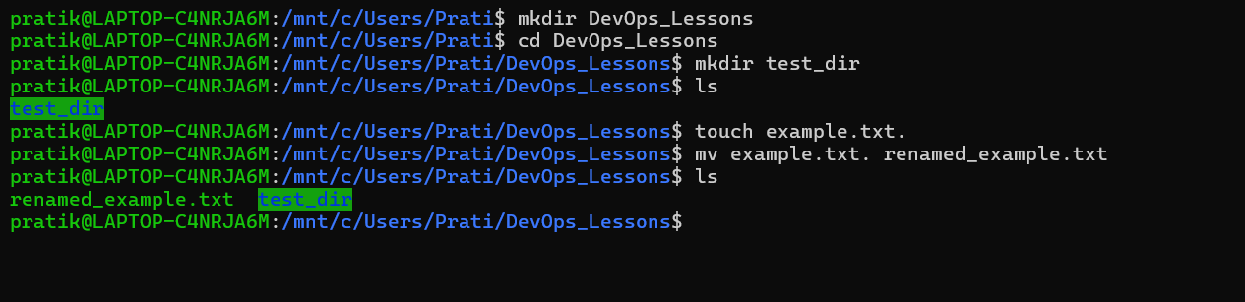

2. Viewing File Contents

Use cat to display the contents of /etc/passwd.

Display only the first 5 lines of /etc/passwd using head.

Display only the last 5 lines of /etc/passwd using tail.

- Used cat to list down all the contents under etc/passwd, used head and tail to display first 5 and last 5 lines of content in it.  
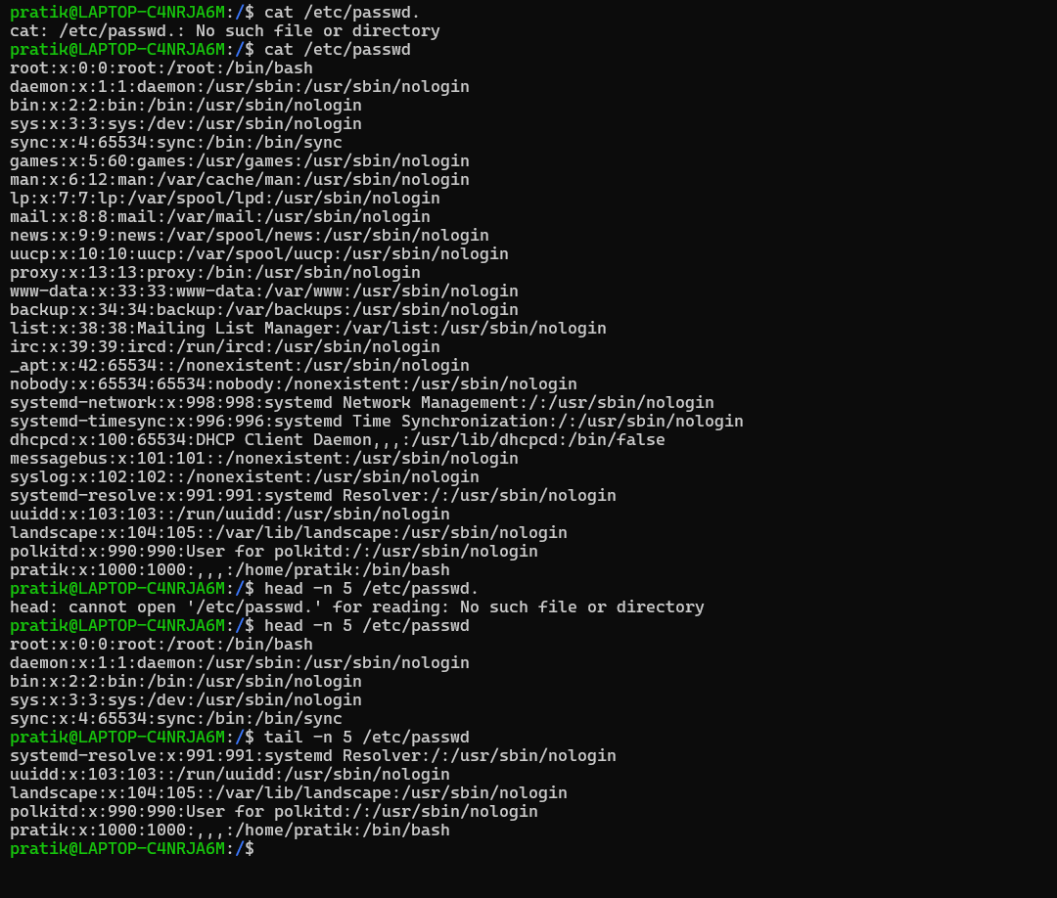

3.Searching for Patterns

Use grep to find all lines containing the word "root" in /etc/passwd.

- Used grep to find out mentions/patterns of “root” in the passwd file

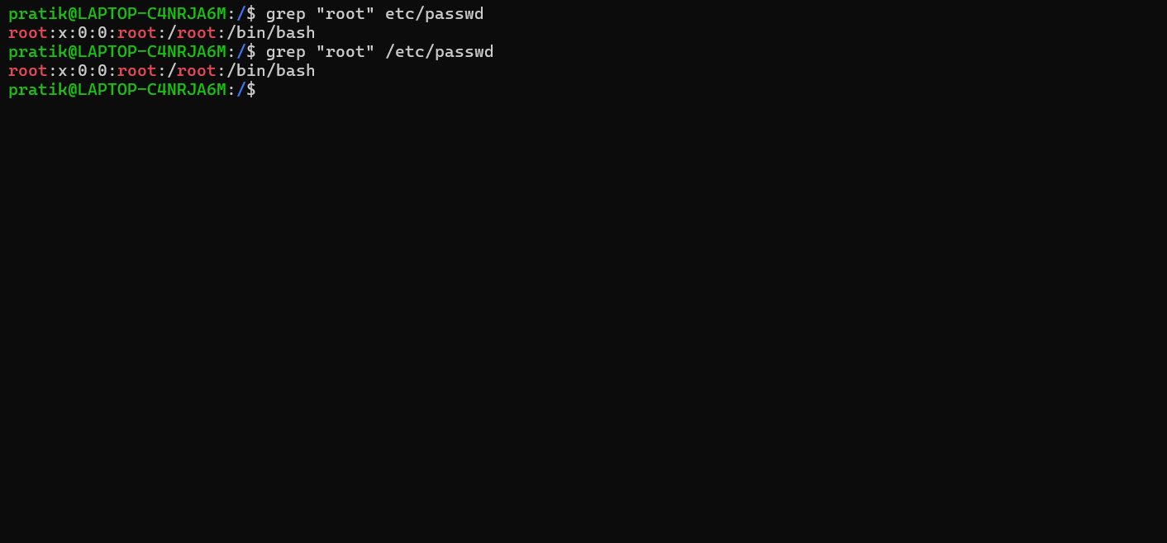

4. Zipping and Unzipping

Compress the test_dir directory into a file named test_dir.zip using zip.

Unzip test_dir.zip into a new directory named unzipped_dir.  
- Zipped & unzipped test_dir as mentioned

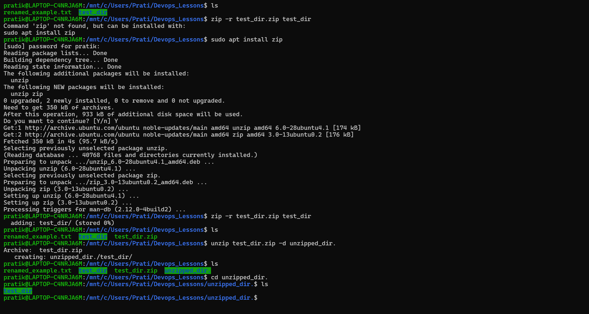

5. Downloading Files

Use wget to download a file from a URL (e.g., <https://example.com/sample.txt>).  
- Used wget to download file from given URL but is kept throwing an error, so I had to use [Google.com](http://google.com) to show.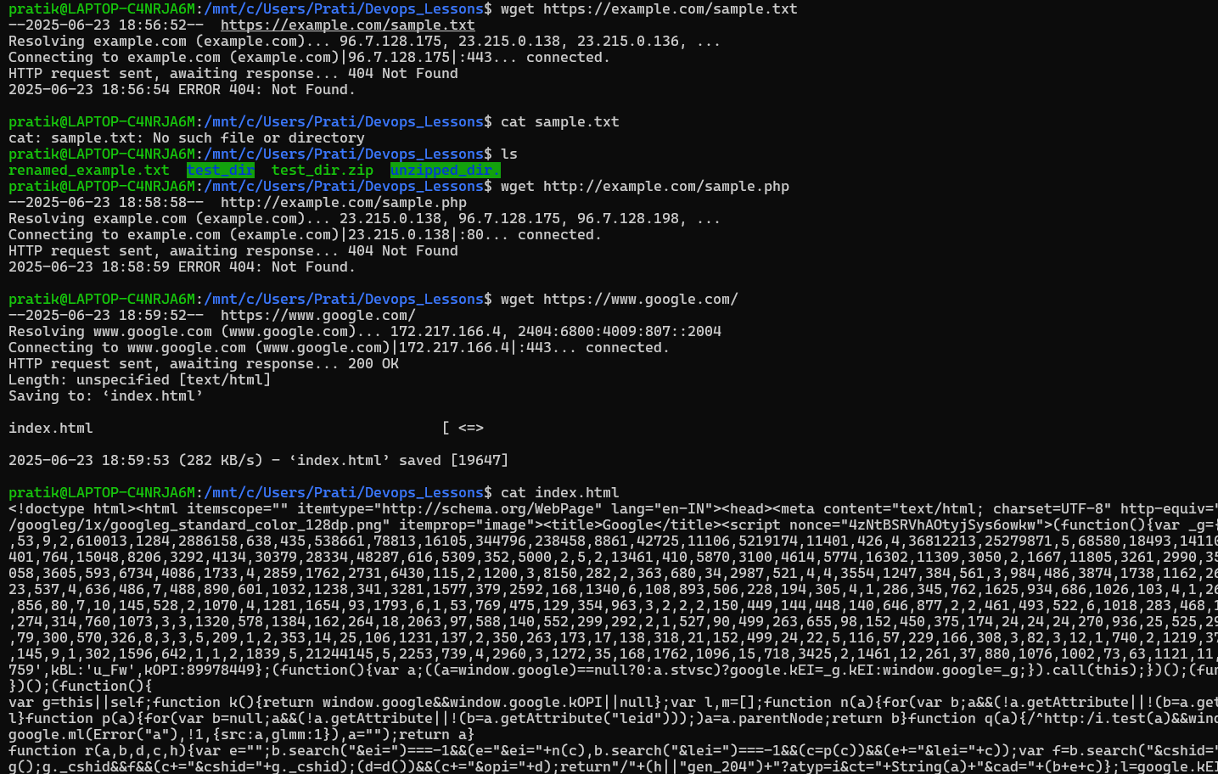

6. Changing Permissions

Create a file named secure.txt and change its permissions to read-only for everyone using chmod.  
- Created a file using touch, added some information in it using echo and changed its permissions to read only using chmod 444 secure.txt but I am using WSL to use Linux, it may have caused the permissions to not completely change the permissions entirely but as the instructor pointed out as well that it is not advisable to change the total permissions. 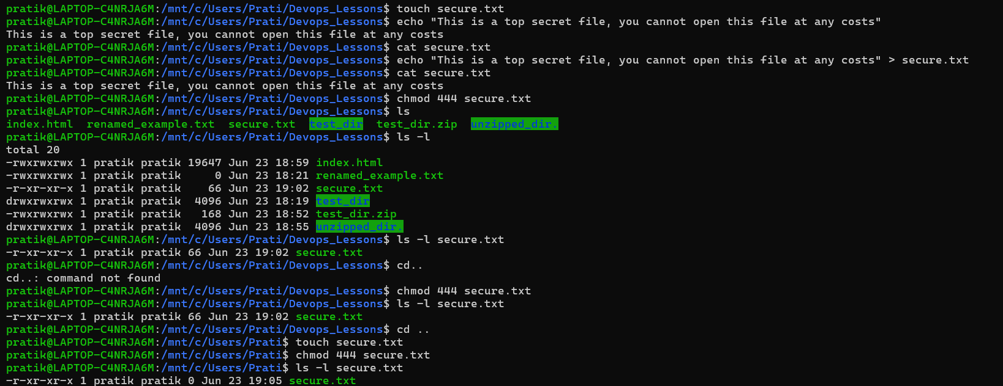

7. Working with Environment Variables

Use export to set a new environment variable called MY_VAR with the value "Hello, Linux!".  
- Used export to create an environment variable MY_VAR for the current session

